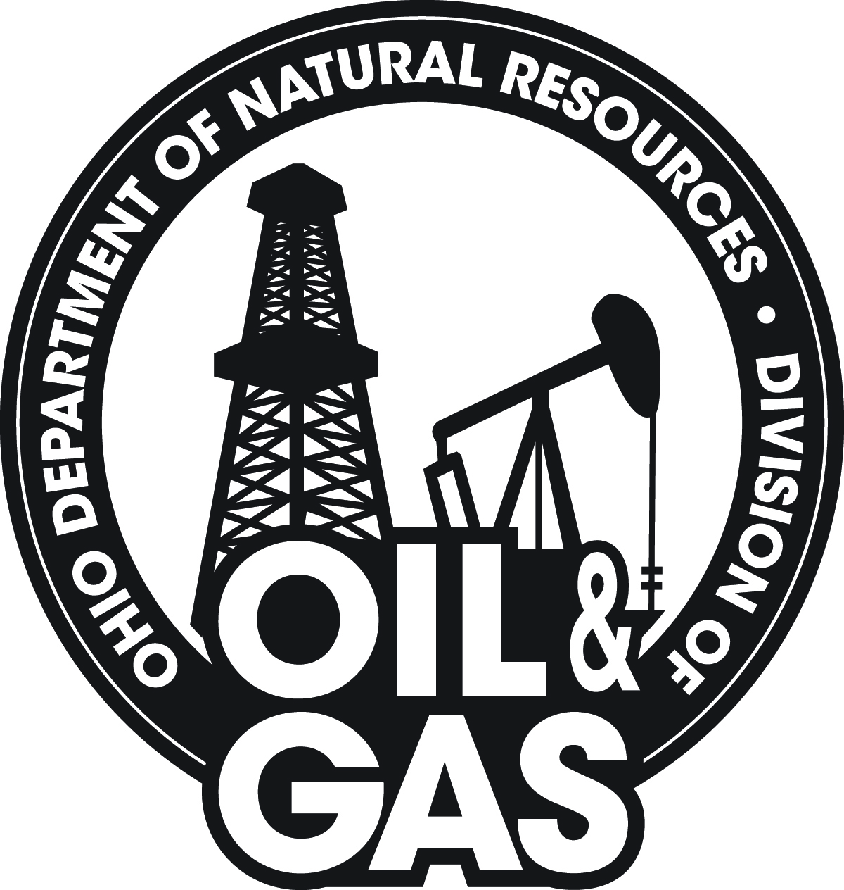 | OHIO DEPARTMENT OF NATURAL RESOURCES  DIVISION OF OIL & GAS RESOURCES MANAGEMENT  2045 Morse Road, F-2 • Columbus, OH 43229-6693 | ODNR Internal Use Only
Orphan Well Landowner Pass-through Payment Plugging Application Rev. 01/17 |  | Owner #:
 |  | I&O Case #:

Applicant Name:
Mailing Address:
City / State / Zip: | / /
Phone:
Email:
Well Name:
API Number:

County:
Civil Township:
Section: |  |  | Lot:
Fraction |  |  | Qtr Township:
Tract/Allot:
Is the well or production facility within an urbanized area as defined by ORC 1509.01 (Y)?

Date of Last Production:
Amount of Oil: | BBL
Amount of Gas: | MCF
Total Depth to be Plugged: | FT
Emergency Numbers Closest to well site.
Fire: |  | Medical:
Means of Ingress and Egress
Road:

Additional Information

This application shall be accompanied by a copy of a proposed contract to plug the well prepared by a contractor regularly engaged in the business of plugging oil and gas wells. The proposed contract shall require the contractor to furnish all of the materials, equipment, work, and labor necessary to plug the well properly and shall specify the price for doing the work, including a credit for the equipment appurtenant to the well that was forfeited to the state as a result of Section (C)(2) of Ohio Revised Code 1509.071.

PRINT NAME |  | PRINT TITLE
SIGNATURE OF OWNER/AUTHORIZED AGENT |  | DATE SIGNED
If signed by authorized agent, a certified copy of appointment of agent must be attached or on file at the division.

