MICHIGAN DEPARTMENT OF ENVIRONMENTAL QUALITY - OIL, GAS, AND MINERALS DIVISION

WELLHEAD BLOWOUT CONTROL SYSTEM  Worksheet supplement for “Application for Permit to Drill or Deepen a Well”  This information is required by authority of Part 615 Supervisor of Wells or Part 625 Mineral Wells, Act 451 PA 1994, as amended, in order to obtain a permit. | Applicant
 | Well name and number
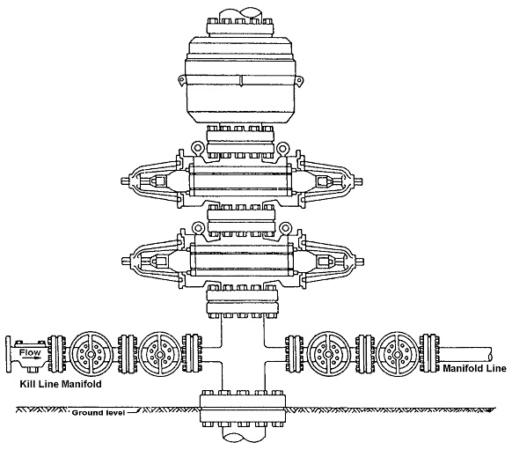  Max. anticipated surface pressure  Annular B.O.P. ”, W.P.  B.O.P. Rams “, W.P.  (Pipe/Blind)  Check Valve “, W.P.  Valve “, W.P.  Valve “, W.P.  Spool “, W.P. | B.O.P.  Manual  Hydraulic  Sour Trim  B.O.P. Rams “, W.P.  (Pipe/Blind)  Valve “, W.P.  Valve “, W.P.  Line ”, W.P.  Wellhead W.P.
Fill above blanks with applicable information. If not applicable, enter “N.A.” or cross-out item shown.
Describe test pressures and procedure for conducting pressure test. Identify any exceptions to R324.406 being requested.

EQP 7200-04 (Rev. 2/2017)

